electronic Devices AND Circuits

Brief Notes
VEEJAR@ECE SEE WWW.WORLDWEBSITES8.BLOGSPOT.COM FOR MORE JNTU
MATERIALS UNIT – I :: ELECTRON DYNAMICS: CRO

- , ‘F’ force on electron in uniform electric field ‘E’
- F=eE; acceleration
- If electron with velocity moves in field making an angle can be resolved to .
- Effect of Magnetic Field ‘B’ on Electron.
- When B & Q are perpendicular path is circular
- When slant with path is # Helical.
- EQUATIONS OF CRT
- ELECTROSTATIC DEFLECTION SENSITIVITY
- MAGNETIC DEFLECTION SENSITIVITY
- Velocity due to voltage V,
- When E and B are perpendicular and initial velocity of electron is zero, the path is Cycloidal in plane perpendicular to B & E. Diameter of Cycloid=2Q, where , , .

UNIT – II :: SEMICONDUCTOR JUNCTION

- have 4 electrons in covalent bands. Valency of 4. Doping with trivalent elements makes , Pentavalent elements makes semiconductor.
- Conductivity where are concentrations of Dopants. are mobility’s of electron and hole respectively.

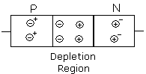
Diode equation

K= Boltzman Constant

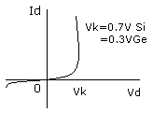
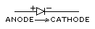

- Diode drop changes , Leakage current doubles on
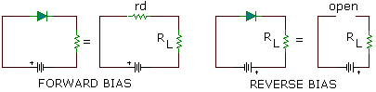

- Diffusion capacitance is of forward biased diode it is

- Transition capacitance is capacitance of reverse biased diode

- RECTIFIERS
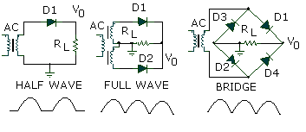

- COMPARISION

 | HW | FW CT | FW BR
Ripple factor
Rectification efficiency
Peak Inverse Voltage |  | 2

UNIT – III :: FILTERS

- Harmonic Components in FW Output,
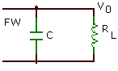
Capacitance Input Filter,
Inductor Input Filter,
Critical inductance
is that value at which diode conducts continuously, in
or
half cycle.

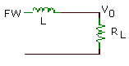
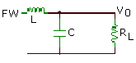
LC FILTER,
or

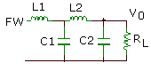
LC LADDER,
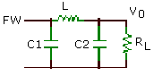
FILTER,
RC FILTER,
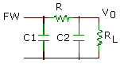

- ZENER DIODE
FWD Bias Normal
Diode 0.7 V Drop

Reverse Bias

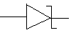

- ZENER REGULATOR
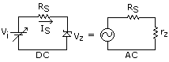

- TUNNEL DIODE
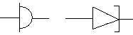

- Conducts in , Quantum mechanical tunneling in region a-0-b-c.
- -ve resistance b-c, normal diode c-d.
= peak current, = valley current; =peak voltage ≈ 65 mV, =valley voltage 0.35 V. Heavy Doping, Narrow Junction , Used for switching & HF oscillators.

- VARACTOR DIODE

Used in reverse bias & as tuning variable capacitance.

- ; n=0.3 for diffusion, n=0.5 for alloy junction,
- is figure of merit, Self resonance

- PHOTO DIODES
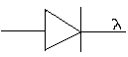

- Diode used in reverse bias for light detection.

- Different materials have individual peak response to a range of wave lengths.

UNIT - IV

- BJT, Bipolar Junction Transistor has 2 Junctions: BE, BC
- Components of current are at junction where
- Emitter efficiency, transportation factor.

Doping Emitter Highest
Base Lowest

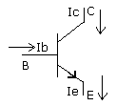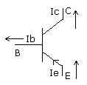

- Leakage currents :

- 3 Configurations are used on BJT, CE, CB & CC

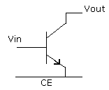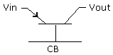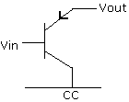

- Common Emitter, VI characteristics

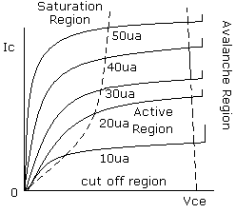
Input Characteristics Circuit Output Characteristics

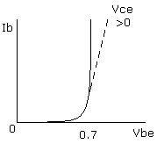

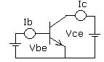

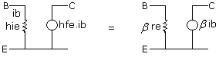
AC Equivalent Circuit

- COMMON BASE VI CHARACTERISTICS
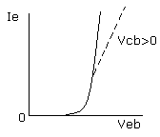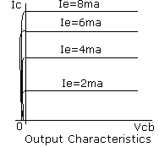

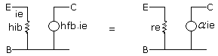
AC Equivalent Circuit

AMPLIFIER COMPARISON
 | CB | CE | CF
 | LOW | MED | HIGH
 | High | High | <1
 | High | High | low

COMPARISON
 | BE | BC
SATURATION | f/b | f/b
ACTIVE | f/b | r/b
CUT OFF | r/b | r/b

UNIT - V
- h- parameters originate from equations of amplifier
are input voltage and current
are output voltage and current
- input impedance
- current gain
- reverse voltage transfer
- output admittance

- FIELD EFFECT TRANSISTOR, FET is Unipolar Device
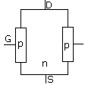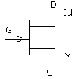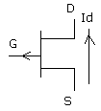
Construction n-Channel p-Channel

- S=Source, G=Gate, D=Drain
- GS Junction in Reverse Bias Always
- Controls Gate Width

- VI CHARACTERSTICS
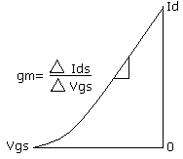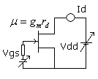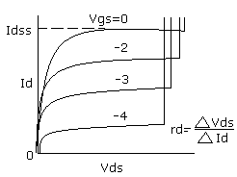
Transfer Characteristics Circuit Forward Characteristics

- Shockley Equation
- ,

- MOSFET: Metal Oxide Semiconductor FET, IGFET
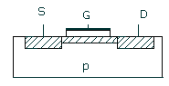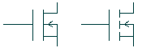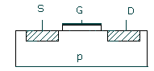
Depletion Type Mosfet Symbols Enhancement Mosfet

- Depletion Type MOSFET can work width and
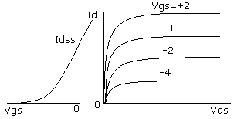
MOSFET | JPET
High
Depletion Enhancement Mode | Depletion Mode
Delicate | Rugged

Transfer Forward
Characteristics Characteristics

- Enhancement MOSFET operates with, ,
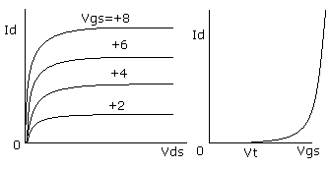
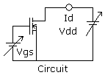

Forward Characteristics Transfer Characteristics

0
0.3
0.5
0

COMPARISIONS
BJT | FET
Current controlled | Voltage controlled
High gain | Med gain
Bipolar | Unipolar
Temp sensitive | Little effect of T
High GBWP | Low GBWP

UNIT – VI :: BIASING in BJT & JFET

- Fixing Operating Point Q is biasing
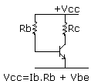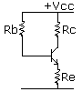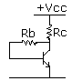
Fixed Bias Emitter Stabilized Feedback Bias
Fixed Bias

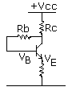

,

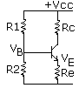

VOLTAGE DIVIDER BIAS EMITTER STABILIZED FIXED BIAS

STABILITY EQUATIONS

- , STABILITY FACTOR
- S must be as small as possible, Most ideal value =1
- How to do determine stability factor for bias arrangement? Derive and substitute in S
- Amplifier formulae: , measured with output shorted
- measured with input shorted
- ;
- H Parameter Model CE
- FET
- CS amplifier
- Common Gate Amplifier
- Common Drain
- RC Coupled Amplifiers
- If cut off frequency ,
- ,
- is beta cut off frequency where
- is cut off frequency where
- is gain bandwidth product.

UNIT – VII :: FEED BACK AMPLIFIERS

- Amplifier gain stands for any of Voltage amplifier, Current amplifier, Trans resistance
Trans admittance amplifier

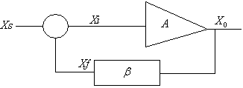

- Ve feed back amplifier depends on
- Feed back reduces noise distortion, gain variation due to parameters, increases BW.
is called de-sensitivity factor.

- Feed back amplifiers
Voltage series, voltage shunt; Current series, current shunt
for voltage, current series
, for all
, for voltage or current shunt
, for current series, shunt
, for voltage series and shunt.

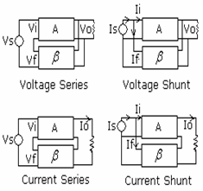

UNIT – VIII :: OSCILLATORS

- Barkausen Criterion for oscillation loop gain =1, =0⁰, 360⁰.

- HARTLEY OSCILLATOR
, , ; , COLLPITS OSILLATOR,
replaced by ,
C replaced by L;

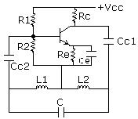

- CRYSTAL OSCILLATORS

- Tuned ckt replaced with Crystal
,

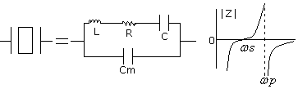

- Phase shift oscillator
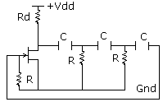
FET MODEL
, ,
Minimum RC sections 3

BJT MODEL ,,
Minimum RC sections 3

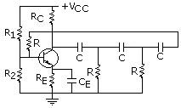

- Wein Bridge Oscillator
,
if R1=R2=R, C1=C2=C , ;

